HackerEarth - Read from STDIN, Write to STDOUT
Code:
#include <stdio.h>

int main() {
int n;
char s[100];
scanf("%d", &n);
scanf("%s", s);
printf("%d\n", n * 2);
printf("%s\n", s);
return 0;
}

Screenshot:
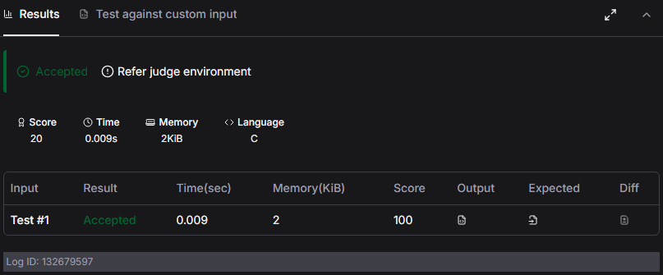

Link:
https://www.hackerearth.com/practice/basic-programming/input-output/basics-of-input-output/practice-problems/algorithm/io-exercise/

